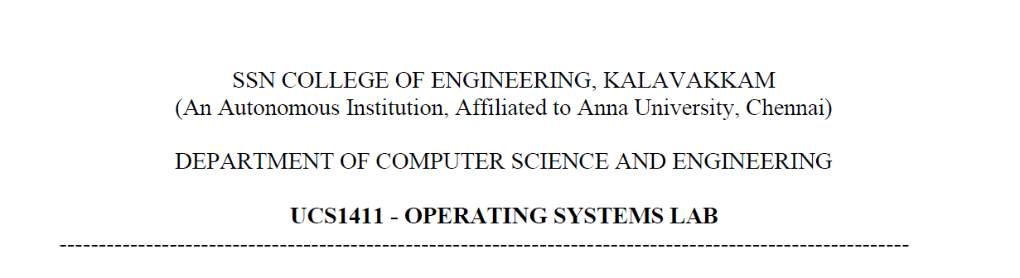

**DBMS - PROJECT PROPOSAL**

|  |  |  |
| --- | --- | --- |
| **Team Name: Project Sandal**  **Group Members** | | |
| S No. | Name | Roll No. |
| 1 | Jayannthan P T | 205001049 |
| 2 | Kishaanth S | 205001054 |
| 3 | Koushik Viswanath S | 205001045 |

**Project Title:** Online Shoe Shopping

**Aim:**

To create an online shoe selling web application using a database management system using oracle.

**Abstract:**

Online Shopping is a web-based application intended for online retailers. The main objective of this application is to make it interactive and its ease of use. It would make searching, viewing and selection of a product easier. It contains a sophisticated search engine for users to search for products specific to their needs. The search engine provides an easy and convenient way to search for products where a user can Search for a product interactively and the search engine would refine the products available based on the user’s input. The user can then view the complete specification of each product. The main emphasis lies in providing a user-friendly search engine for effectively showing the desired results and its drag and drop behaviour.

**Description:**

We create a database where the admin inputs the data of the shoes that arrive on a frequent basis based on the requirement which has the options like size, brand, color etc. the user orders a product from the website. The customer can look upto the details and the actions taken after the date of order until the date of delivery.

**Technology Used:**

* Oracle server for database
* Html, CSS, JavaScript
* ReactJS

**Applications Used:**

* + VScode
  + Oracle database server
  + Github

Entity Relational Model